**Project Design Phase-II Technology Stack (Architecture & Stack)**

|  |  |
| --- | --- |
| Date | 02 NOVEMBER 2022 |
| Team ID | PNT2022TMID31045 |
| Project Name | Real time river water quality monitoring and control system |
| Maximum Marks | 4 Marks |

**Technical Architecture:**

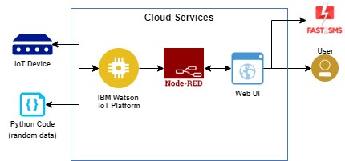

|  |  |  |  |
| --- | --- | --- | --- |
| **S.No** | **Characteristics** | **Description** | **Technology** |
| 1. | Open-Source Frameworks | App development and Machine learning model development | Python Script |
| 2. | Security Implementations | IBM cloud service  IBM Watson IoT platforms and Device Node -Red Service | e.g. SHA-256, Encryptions, IAM Controls, OWASP etc. |

**Table-1 : Components & Technologies:**

|  |  |  |  |
| --- | --- | --- | --- |
| **S.No** | **Component** | **Description** | **Technology** |
| 1. | User Interface | Web UI | HTML, CSS, JavaScript |
| 2. | Application Logic-1 | Web UI to enter the Register/login | HTML,CSS,JavaScript |
| 3. | Application Logic-2 | Get the river body data from the cloud | IBM Watson IoT API call data |
| 4. | Application Logic-3 | Set some threshold values for the data set and alert the user about the abnormalities | IBM Watson Assistant |
| 5. | Database | Dissolved oxygen,pH,Ammonia,Chloride levels | MySQL |
| 6. | Cloud Database | Call the data IBM Cloudant is used and user login credentials | IBM DB2, IBM Cloudant |
| 7. | File Storage | Web UI code and ioT credentials are stored and API keys | IBM Block Storage |
| 8. | External API-1 | To get the user login credentials to find the data they require | IBM Login API |
| 9. | External API-2 | To get the data set of the water quality monitored by the sensor network | Monitoring API |
| 10. | Machine Learning Model | For interfacing hardware and software applications(a virtual wiring tool) | Platforms:Node.js. |
| 11. | Infrastructure (Server / Cloud) | Application Deployment on Cloud  Cloud Server Configuration : :application-client-end | IBM Cloud |

**Table-2: Application Characteristics:**

|  |  |  |  |
| --- | --- | --- | --- |
| **S.No** | **Characteristics** | **Description** | **Technology** |
| 3. | Scalable Architecture | As the proposed system involves only three sensors,the application can be easily developed into many numbers | IoT |
| 4. | Availability | Maximum down time will be about 4 hours | IoT |
| 5. | Performance | Load time for user interface Screen shall not be more than 2 seconds.  Login info verified within 10 seconds.. | IoT |